OLD HOME DAY – SATURDAY, SEPTEMBER 19, 2026 RESERVATION FORM
​
TENTS MUST BE SECURED WITHOUT THE USE OF STAKES. WE DO NOT PROVIDE TABLES, TARPS, CHAIRS OR TENTS.
NO ELECTRICAL HOOKUPS ARE AVAILABLE. ​
No refunds will be issued upon approval of application.

By signing below, I understand and agree to comply with all policies set forth and noted on the Old Home Day – 2026 reservation form. I understand that non-compliance will result in the closing of my space without a refund.

SIGNATURE: ___________________________________________________ DATE: _________________
PRINTED NAME: ______________________________________________________________________
PHONE: ______________________ EMAIL (required)​ :​ ______________________________________
BUSINESS NAME: _____________________________________________________________________ ADDRESS: ___________________________________________________________________________
CITY/TOWN: _____________________________________ STATE: ________ ZIP: _________________
DESCRIPTION OF YOUR CRAFT: __________________________________________________________
___________________________________________________________________________________
SPECIAL ACCOMMODATIONS/REQUESTS: We attempt to honor requests for booth spaces, although we cannot guarantee that they will be met, applications are processed in order of the date received with payment. Applications without payments will not be processed.
********************************************************************************************
Please indicate the type and number of 12’ x 12’ space requested on the lines below:
For Office Use:
Date received ________________
Check # _____________________
Check amount _______________
Other ______________________
- ________ Standard Crafter Space @ $125 per space
- ________ Prime Crafter Space @ $150 per space SOLD OUT
- ________ Standard Business Space @ $150 per space
- ________ Prime Business Space @ $175 per space SOLD OUT
- ________ Non-profit Standard Space @ $50 per space
- ________ Non-profit Prime Space @ $85 for the space (only one allowed per vendor) SOLD OUT
In addition to the space fee, I understand I am expected to donate a basket for the Penny Sale. (initial here_____)

Make checks payable to: First Congregational Church of Pelham. You will receive confirmation/approval of your application via email. Specific space details are emailed in September prior to the event.
We must receive your reservation form and payment by Monday, AUGUST 31, 2026 (​ $50.00 late fee after the 31st)
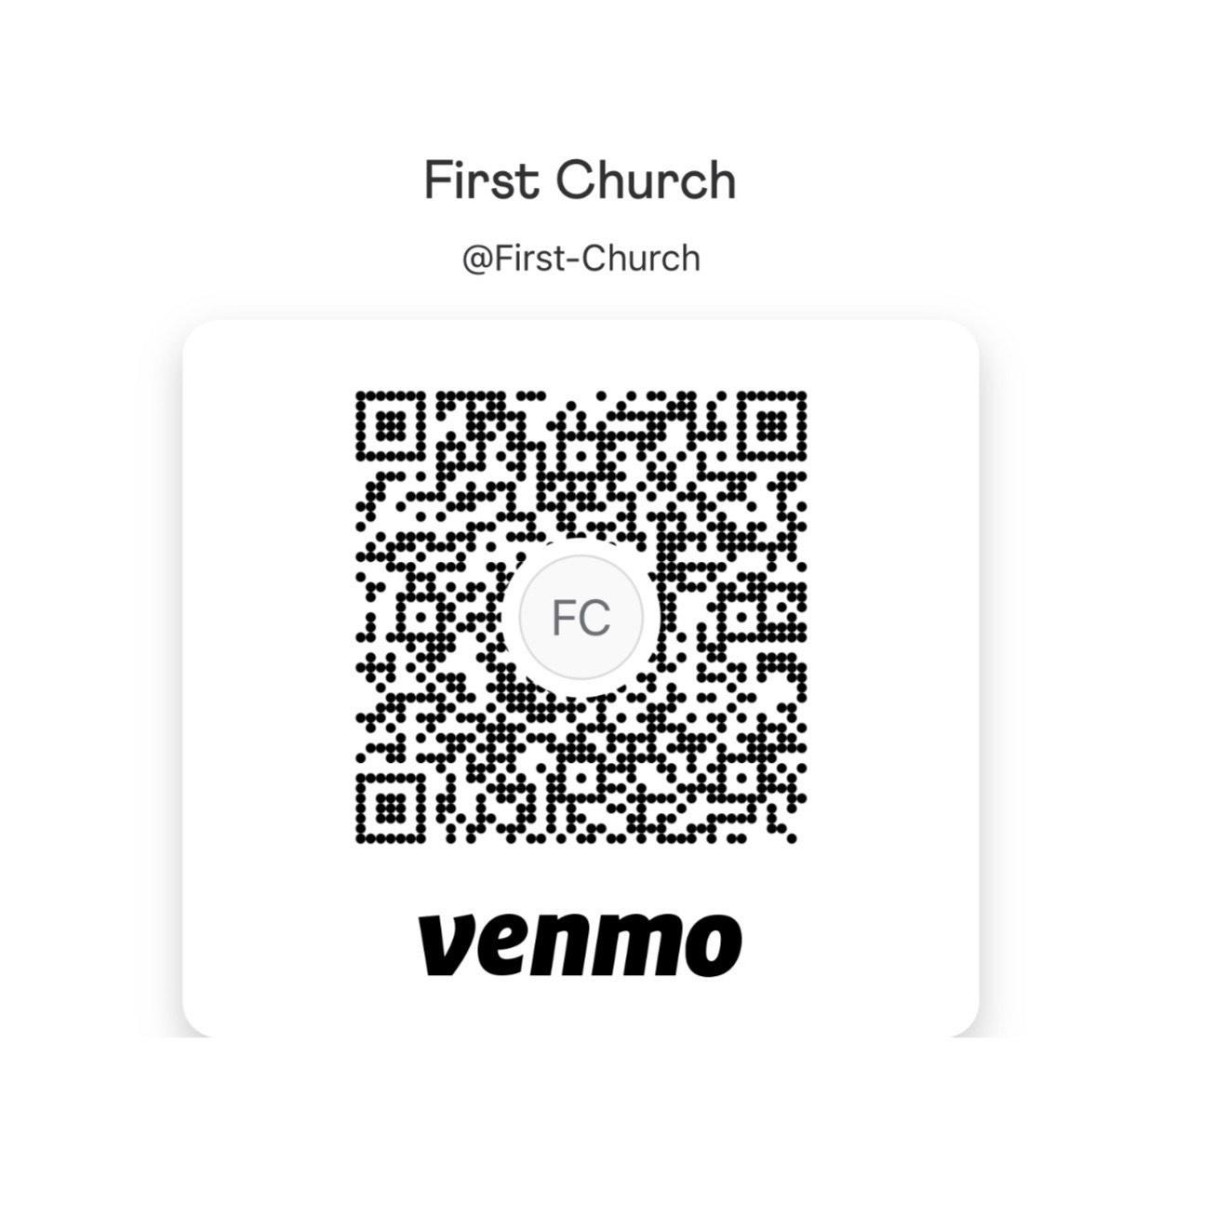
Return your reservation form and payment​ to:​
For Venmo payments, please include the following in the memo:
- Business name
- Vendor name
- Type of space requested

First Congregational Church, UCC
Old Home Day Vendor Reservations
3 Main Street, Pelham, NH 03076
FIRST CONGREGATIONAL CHURCH, UCC ​ ​
3 Main Street ​ ​
PELHAM, NH 03076 ❖​ ​ 603-635-7025
More information about Old Home Day is available at: ​http://www.pelhamoldhomeday.org

Set up details:
- Tents and tables may be set up anytime on Friday September 18th. Set up time is from 6:00 – 8:30 am on the morning of the event. All vehicles must be moved from the church grounds by 8:30am on the morning of Old Home Day.
- TENTS MUST BE SECURED WITHOUT THE USE OF STAKES.
- FREE ​parking is available at St. Patrick’s Church or The Village Green.
- Plan to leave your space set up until 4:30 pm.
- No electrical hooks will be provided, no generators are allowed in the vendor area.

Fees and Space details:​ (​ All fees are non-refundable) ● Standard fees: $125 crafters, $150 businesses
- Prime fees: $150 crafters, $175 businesses (these are spaces located on the main outside walkways with high exposure)
● A nominal fee of $50 will be charged for non-profit organizations​ ​(non-profit space is limited and available based on sponsor discretion). There are a limited number of prime non-profit spaces available for $85.00. Non-profit organizations include church, civic and social organizations holding 501C designation and will be located in our Community Corner.
- In addition to the fee, we request that each ​vendor/crafter donate a basket for our Penny Sale Raffle​. The basket can be dropped off with one of your business cards when you set-up on the morning of September 19th (or on the 18th if you set up on Friday).
- All canopies, tables and chairs are the responsibility of the vendor/crafter.
- Canopies must be no larger than 12’ x 12’​ and cannot overlap into designated walkways or neighboring booths, if the canopy is larger than 12’ x 12’, then additional space must be reserved.
- Deadline for securing space is Monday, August 31, 2026. Please note we sold out of all spaces last year prior to the deadline.
- ​ALL APPLICATIONS RECEIVED IN THE OFFICE 9/1/26 AND AFTER WILL BE ASSESSED A $50.00 LATE FEE.
Restrictions: Non-compliance with these restrictions will result in your space being closed with no refund. ​
- We ​DO NOT​ allow spaces for controversial subject matter as determined by the OHD Committee. Pelham restricts the sale/use of weapons or weapon like toys (guns, swords, knives, mace, stun guns, bang caps, etc.) and/or nuisance items (silly string, disappearing ink, etc.) We also restrict the sale of adult themed items.
- Vendors must remain in their designated/assigned booth area, there should be no walking amongst booth or event grounds to sell or distribute information. (No smoking in booths.)
- RAFFLES ARE NOT ALLOWED. The only raffle permitted is run by the OHD committee. ​ You can hold ​drawings for goods or services, as long as there is NO CHARGE to participate.

- OHD Committee reserves the rights to decline applications with duplicate services. ​Non-profit organizations are not allowed to provide services that full price paid vendors are providing, i.e. face painting.

- The Old Home Day staff is comprised of many volunteers who work hard for the benefit of our community. Please treat all staff respectfully.

Space Reservations:
- Make check payable ​to First Congregational Church, UCC​. We cannot accept post-dated checks.
- Completed forms must be received by Monday, August 31, 2026 to avoid a late fee. ​ ​
- All confirmations/receipts will be sent via email.
- An online copy of this form can be found on the OHD website: https://www.pelhamoldhomeday.org
Please retain a copy of this form for your information regarding ​Old Home Day 2026 ​policies. Thank you!

